**RECRUITMENT SYSTEM**

**PROBLEM STATEMENT:**

1. Recruitment system was developed in companies for interviewing the employee.

2. The system could contain the following features.

**3**. The system should provide information about queries, database etc.

**4.** The system explains about the employees attending interview and HR asking query to the employee.

**5.** The following process takes place when recruiting the employee.

**6**. Employee gives details to the interviewer.

**7**. Then the employee waits for the result.

**8**. Finally employee quit from process.

**9.** The details about the employee will be updated in database.

**SOFTWARE REQUIREMENT SPECIFICATION**

**INTRODUCTION** :

Viewing available jobs, or applying for the job at the agency is currently done manually where in the job seekers has to go to the agency and check the available jobs at the agency. Job seekers check the list of jobs available and apply the job if the job is not available otherwise it is of waste for the job seeker to come to the agency to come to check for the job if the job seeker doesn’t get the job. Then the agency will show available jobs for the job seeker for his qualifications and the then updates the jobs database.

**PURPOSE**:

The purpose of Software Requirements Specification (SRS) document is to describe the external behavior of the Online Recruitment System. Requirements Specification defines and describes the operations, interfaces, performance, and quality assurance requirements of the Online Recruitment System. The document also describes the nonfunctional requirements such as the user interfaces. It also describes the design constraints that are to be considered when the system is to be designed, and other factors necessary to provide a complete and comprehensive description of the requirements for the software. The Software Requirements Specification (SRS) captures the complete software requirements for the system, or a portion of the system. Requirements described in this document are derived from the Vision Document prepared for the Online Recruitment System.

**SCOPE**:

The Software Requirements Specification captures all the requirements in a single document. The Online Recruitment System that is to be developed provides the members with jobs information, online applying for jobs and many other facilities. The Online Recruitment System is supposed to have the following features.

**OVERVIEW:**

The SRS will provide a detailed description of the Online Recruitment System. This document will provide the outline of the requirements, overview of the characteristics and constraints of the system.

**OVERALL DESCRIPTION**

**1. PRODUCT PERSPECTIVE:**

The Online Recruitment System is a package to be used by agencies to improve the efficiency of business. The Online Job Portal System to be developed benefits greatly the members. The system provides jobs catalog and information to members and helps them decide on the jobs to apply. The Admin can keep the jobs catalog updated all the time so that the members (Job seekers and the agencies) get the updated information all the time.

**PRODUCT FEATURES:**

**Jobseekers Features** :

* Advanced job search functions
* Register for a jobseekers account
* Build your profile
* Build online CV
* Build multiple cover letters
* Upload Word CV
* Paste your Word CV
* Enable/Disable your CV's
* Receive jobs via email
* Enable/Disable email alerts
* Save jobs in your Jobs Inbox
* Apply to job vacancies instantly
* View previous applications
* Upload personal photo
* Easy to use interface
* Retrieve login information via email.

**Agencies Features** :

* Advanced CV search functions
* View detailed bills.
* Purchase advertising credits via credit card.
* Enable/Disable CV database access.
* Advertise job vacancies instantly.
* Edit/Delete job vacancies.
* Upload company logo.
* Purchase jobseeker contact details.
* Save jobseeker CV's in CV Inbox.
* Hide contact details on job postings.
* Specify application rules for each job posting.
* Receive application alerts via email.
* View/Delete applicant CV's.
* View applicant cover letters.

**Administration Features :**

Multiple administration accounts  
Live statistics  
Create resources  
Create multiple job categories with subcategories  
Create countries with regions and cities  
Specify working hours, contracts and experience levels  
View/Edit/Delete jobseekers  
Email individual jobseekers  
View/Edit/Delete employers  
Email individual employers  
Upgrade/Downgrade agency accounts  
Upload company logos  
View jobs for each agency  
Add/Edit jobs for each specific agency  
Advanced mailing system

Advanced content management system

Add unlimited pages of content

**PRODUCT FUNCTIONS:**

The Online Recruitment System provides online real time information about the jobs available in the agencies and the user information. The Product functions are more or less the same as described in the product perspective. The functions of the system include the system providing different type of services based on the type of users [Member/Admin].

* The member should be provided with the updated information about the jobs catalog.
* Provisions for the members to apply the job they want, if all the other required rules hold good.
* The member is given a provision to check his account information and change the account information any time in the given valid period.
* The members are provided with the jobs available roster and allowed to apply job, which they want.
* The admin can get the information about the members who have advertised jobs.
* The admin can get the information about the members who have applied jobs.
* The admin is provided with interfaces to add/delete the jobs available in the job catalog.
* The job seeker when complete the applying, the due to be paid by the agency must be calculated and the information about the agency and the due amount is sent to the billing system.
* The system uses the University information security requirements to provide the login facility to the users.

**1.Operating Environment :**

There should be proper commitment of Hardware and communication  
gears should be equally coupe with each other, it may help to prevent  
many inconveniences during the Browsing. Those requirements have  
been Explained later headings. (Please refer to Performance  
Requirements on Heading 5.1).

* Web Browsers [Java Script enabled]
* Google Chrome
* Internet explorer
* Mozilla Firefox
* Operating Systems and versions.
* All the Windows OS versions

.

**USER CHARACTERISTICS:**

The users of the system are members and the admin who maintain the system. The members are assumed to have basic knowledge of the computers and Internet browsing. The admin of the system to have more knowledge of the internals of the system and is able to rectify the small problems that may arise due to disk crashes, power failures and other catastrophes to maintain the system. The proper user interface, user’s manual, online help and the guide to install and maintain the system must be sufficient to educate the users on how to use the system without any problems.

**CONSTRAINTS:**

* The information of all the users must be stored in a database that is accessible by the Online Job Portal System.
* The Online Job Portal System is connected to the computer and is running all 24 hours a day.
* The users access the Online Job Portal System from any computer that has Internet browsing capabilities and an Internet connection.
* The billing system is connected to the Online Job Portal System and the database used by the billing system must be compatible with the interface of the Online Library System.
* The users must have their correct usernames and passwords to enter into the Online Job Portal System.

**ASSUMPTIONS AND DEPENDENCIES:**

* The users have sufficient knowledge of computers.
* The Computer should have Internet connection and Internet server capabilities.
* The users know the English language, as the user interface will be provided in English
* The product can access the member’s database.

**SYSTEM FEATURES:**

**Jobseeker :**

* Advanced job search functions.
* Register for a jobseekers account.
* Build your profile.
* Build online CV.
* Build multiple cover letters.
* Upload Word CV.
* Paste your Word CV.
* Enable/Disable your CV's.
* Receive jobs via email.
* Enable/Disable email alerts.
* Save jobs in your Jobs Inbox.
* Apply to job vacancies instantly.
* View previous applications.
* Upload personal photo.
* Easy to use interface.
* Retrieve login information via email.
* Forward job vacancy to a friend.

**Agency :**

* Advanced CV search functions.
* Purchase advertising credits via credit card or invoice.
* Enable/Disable CV database access.
* Advertise job vacancies instantly.
* Edit/Delete job vacancies.
* Upload company logo.
* Do payment for jobseeker contact details.
* Save jobseeker CV's in CV Inbox.
* Hide contact details on job postings.
* Company logo displayed by job postings.
* Specify application rules for each job posting.
* Receive application alerts via email.
* View/Delete applicant CV's.
* View applicant cover letters.

**Administration :**

* Multiple administration accounts
* Live statistics
* Accept payments.
* View/Edit agencies account balance.
* Send account balance report via email to agencies.
* Create resources
* Create multiple job categories with subcategories
* Create countries with regions and cities
* Specify working hours, contracts and experience levels
* View/Edit/Delete jobseekers
* Email individual jobseekers
* View/Edit/Delete agencies
* Email individual agencies
* Upgrade/Downgrade agency accounts
* Upload company logos
* View jobs for each agency
* Add/Edit jobs for each specific agency
* Advanced mailing system.
* Advanced content management system
* Add unlimited pages of content
* Customize the job board to meet your exact requirements

**Specific Requirements**

This section describes in detail all the functional requirements.

**Functionality**

**Logon Capabilities**

The system shall provide the users with logon capabilities.

**Mobile Devices**

The Online Job Portal System is also supported on mobile devices such as cell phones.

**Alerts**

The system can alert the in case of any problems.

The languages that shall be used for coding Online Job Portal System are Java Servlets, Java Server Pages (JSP), and HTML. For working on the coding phase of the Online Library System, the Internet Information Services (IIS) Server needs to be installed.

**Development Tools :**

We will make use of the available Java Development Tool kits for working with Java Beans and Java Server Pages. Also we will make use of the online references available for developing programs in HTML.

**Class Libraries**

We will make use of the existing Java libraries available for JSP and Servlets. Also we need to develop some new libraries for the web- based application. Also we will develop new programs using scripting languages.

**On-line User Documentation and Help System Requirements**

Online help is provided for each of the feature available with the Online Job Portal System. All the applications provide an on-line help system to assist the user. The nature of these systems is unique to application development as they combine aspects of programming (hyperlinks, etc) with aspects of technical writing (organization, presentation). Online help is provided for each and every feature provided by the system.

The User Manual describes the use of the system to Admin. It describes the use of the system on mobile systems. The user manual should be available as a hard copy and also as online help.

An installation document will be provided that includes the installation instructions and configuration guidelines, which is important to a full solution offering. Also, a Read Me file is typically included as a standard component. The Read Me includes a “What’s New With This Release” section, and a discussion of compatibility issues with earlier releases. Most users also appreciate documentation defining any known bugs and workarounds in the Read Me file.

Since the installation of Online Job Portal System is a complex process, our experts will do it. So an installation Guide will not be provided to the user.

**Purchased Components**

The System Administrator will need to purchase the license for IIS Server. Mostly it is available with Windows Environment. So the system need not purchase any licensing products.

**Interfaces :**

**User Interfaces**

The entire user Interfaces will provide with Final Project

Documentation in Later.

**Hardware Interfaces**

Hardware interfaces and all the functional Interfaces been describe

in Performance Requirements.

**Software Interfaces**

A firewall will be used with the server to prevent unauthorized access

to the system.

Database Design

My SQL and My SQL Control center

Graphic Designing

Adobe Photoshop CS3, Dreamweaver CS3

Advanced Tools

Net Beans 6.1 and J.D.K 6.0

**Communications Interfaces :**

The Online Job Portal System will be connected to the World Wide Web.

The HTTP protocol will be used to facilitate communication between the client and server.

**Other functional Requirements.**

**Performance Requirements**

Server Side

The web application will be hosted on one of the windows server.

The ideal specifications for the server machines.

• Intel Core 2 Duo Extreme – 2 GHz

• 8GB of RAM

• Running Windows Server

• A commercial Web Application Server

• At least five 3rd party machines for clustering.The minimal specifications for the server machine.

• Intel Core 2 Duo – 1.86 GHz

• 2GB of RAM

• Running Windows XP

• Apache Tomcat Server

Client Side

The system is a web based application clients are requiring using modern web browser such as Mozilla Firefox 1.5, Internet Explorer 6 and Enable cookies.

•The ideal requirement for a client PC logging into the

system.

•Intel Pentium IV or equivalent processor – 2.0 GHz or above

**Safety Requirements**

Highly recommend Kaspersky 2010 internet security to been Installed in users Pc to prevent the harm that may occurs by Unwanted malicious software’s, phishing URLs and all the types of Virus attacks during using this application..

**INDEX:**

Not applicable.

**USE CASE DIAGRAM:**



**USE CASE DIAGRAM:**

FULL DETAILS:

Employee can give full details to the interviewer.

SELF INTRODUCTION:

Employee give self introduction to HRD in interview.

QUERY:

HR asks the queries during the interview from employee.

REPLY:

Employee replies for the queries to HRD.

EXPERIENCE:

Database has been updated from an employee.

COMPANY:

He has to give self introduction about his old company.

UPDATE DATABASE:

Database is updated for an employee.

ACTIVITY DIAGRAM:



**ACTIVITY DIAGRAM:**

FULL DETAILS:

The employee can give full details to the HRD during the interview process.

SELF INTRODUCTION:

Employee gives self introduction to the HRD in the interview.

QUERY:

HR ask the queries during the interview from employee.

REPLY:

Employee replies for the queries to the HRD.

COMPANY:

He has to give self introduction about himself.

UPDATE DATABASE:

Database has been updated for each employee of the organization.

WAIT FOR REPLY:

Employee has to wait for result until they give a call from an organization.

QUIT:

After getting his offer letter the employee has to proceed on it, if not he has to try for some other organization.

**CLASS DIAGRAM:**



**CLASS DIAGRAM**:

EMPLOYEE:

Employee is a person has to be prepared for the interview. He can fill the application form and register

INTERVIEWER:

Interview is taken by the HRD for employee job.

HRD:

HRD is a person who is taking the interview. He can select an employee and suggest his job.

DATABASE:

Database have been updated for an employee.

SEQUENCE DIAGRAM:



**SEQUENCE DIAGRAM:**

EMPLOYEE:

Employee gives the full details about him for the interview.

GIVES FULL DETAILS:

Employee can gives full details to the HRD during interview.

SELF INTRODUCTION:

Employee gives the self introduction to HRD during the interview.

QUERY:

HRD ask the queries in the interview.

PROCESS CONTINUES:

This process continues for all the candidate during HR interview.

REPLY:

Employee replies for the queries.

WAITING FOR RESULT:

Employee has to wait for the result until they give a call from an organization.

QUIT:

After getting his offer letter the employee has to proceed on it,if not he has to try for some other organization.

COLLABORATION DIAGRAM:



**COLLABORATION DIAGRAM:-**

GIVE DETAILS FILES:-

Employee can give the full details to the HRD**.**

SELF INTRODUCTION:-

Employee gives the self introduction to the HRD in interview.

QUERY:

HR ask the queries during the interview from employee.

REPLY:

He replies for the queries to the HRD.

EXPERIENCE:

Employee have any other experiences in any organization.

COMPANY:

He has to tell self introduction about his company.

UPDATE DATABASE:

Database has been updated for each employee of an organization.

WAIT FOR RESULT:

Employee has to wait for result until they give up a call from an organization.

**STATE CHART DIAGRAM:**



**STATE CHART DIAGRAM:**

DETAILS:

Employee has to give full details to the HRD during the interview.

SELF INTRODUCTION:

Employee gives self introduction to the HRD in interview.

QUERIES:

Query will be asked during the interview by the HRD.

REPLY:

Employee replies for the queries during the interview.

UPDATE DB:

Database have been updated for each employee.

WAITING FOR RESULT:

Employee has to wait for the result.

LOGICAL LAYER ARDHITECTURE:

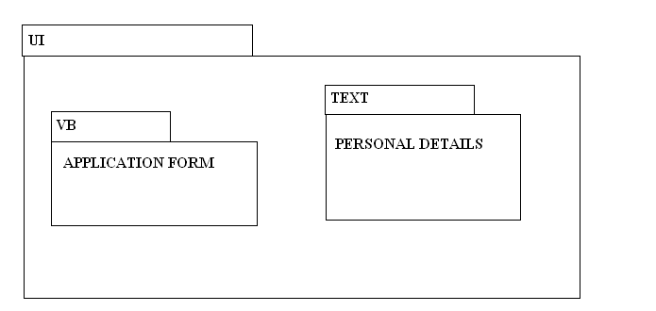

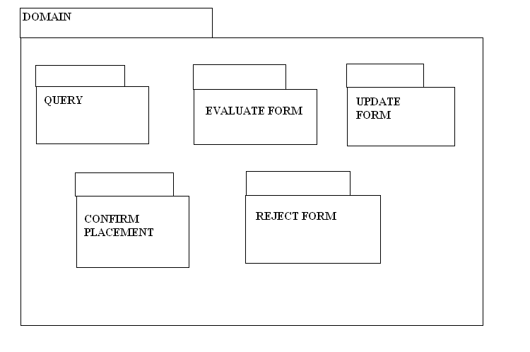

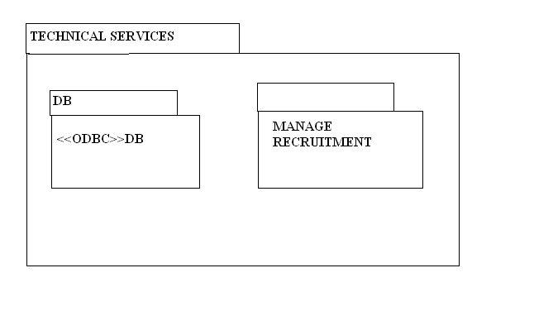

**TECHNICAL SERVICES**

**DOMAIN LAYER:**



**USER INTERFACE LAYER:**



COMPONENT DIAGRAM:

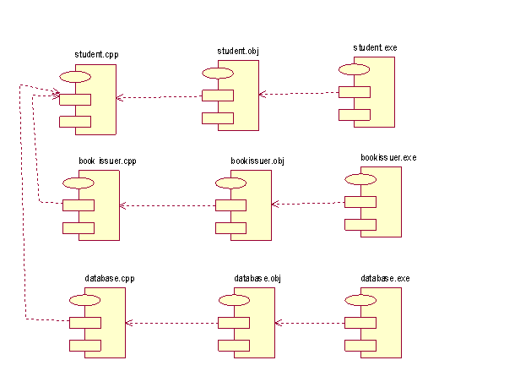

**COMPONENT DIAGRAM:**

EMPLOYEE:

Employee is a person has to be well prepared for the interview.he can enter the application form and register it.

INTERVIEWER:

Interview is taken by the HRD for the employee’s job.

HRD:

HRD is a person who is taking the interview and giving job to the employee.

DATABASE:

Database has been updated for an employee in particular organization.

DEPLOYMENT DIAGRAM:

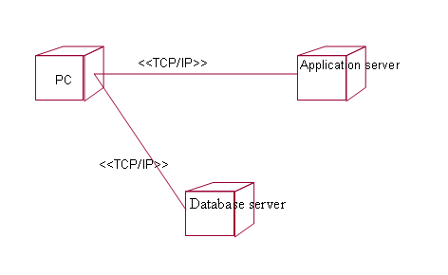

**DEPLOYMENT DIAGRAM:**

PC:

PC is the personel computer .It contains the details about the employee. he employee end of from to the HRD during interview.It follows the details and he has to provide the full details about his resume.

APPLICATION SERVER:

It is a deployment that shows the mapping of process. The application server requires the employee details and be updated to the particular organization. It uses the protocol TCP/IPfor updating the details of an employee.

DATA SERVER:

Data server contains the details about an employee during HR interview. The particular details can been updated for the interview process.

**Conclusion:**

Thus the recruitment system for use case diagram, class diagram, sequence diagram, collaboration diagram,statechart diagram, component diagram,deployment diagram are implemented successfully.